Design Document

Spiers Magic Wand

A- Team

Hardware Schematic:

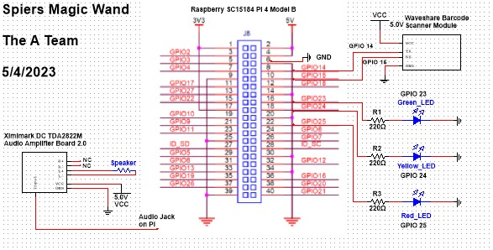

Wire Diagram:

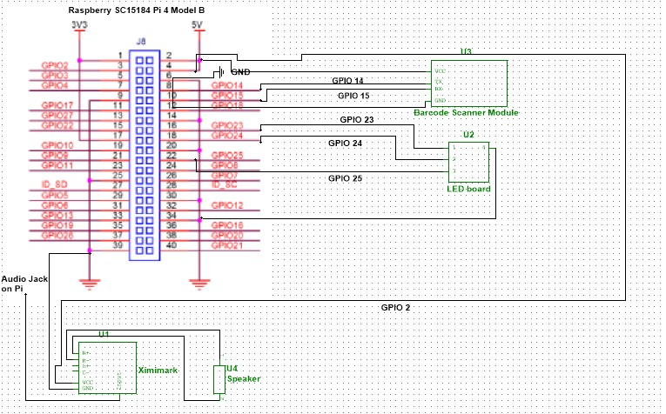

Raspberry Pi 4:

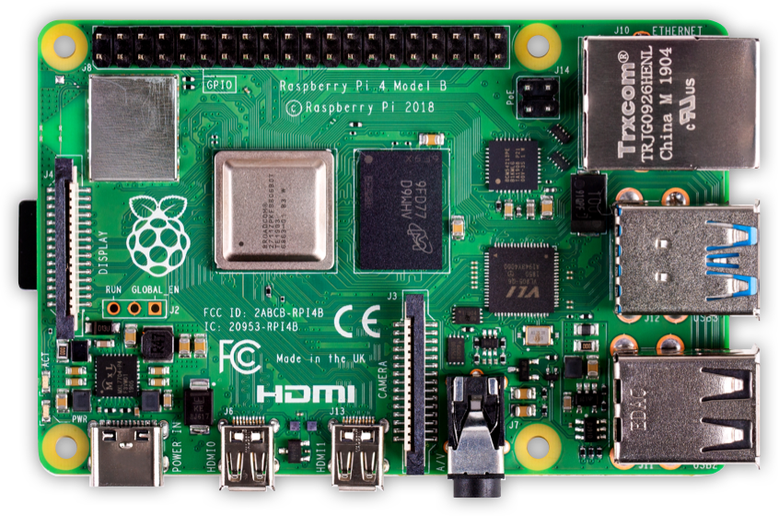

The purpose of the raspberry pi 4 is to act as the computer for the system. It also acts as the main power source for all of the components excluding the battery. The reason we chose this specific microcontroller for our project is because it has the necessary processing power for our desired functions. It also has wifi capability, meaning it can connect to web services and servers.After receiving power from the battery pack, the raspberry pi distributes voltage to the rest of the system. The microprocessor also controls the LEDs, audio amplifier, and barcode scanner.

Waveshare Barcode Reader:

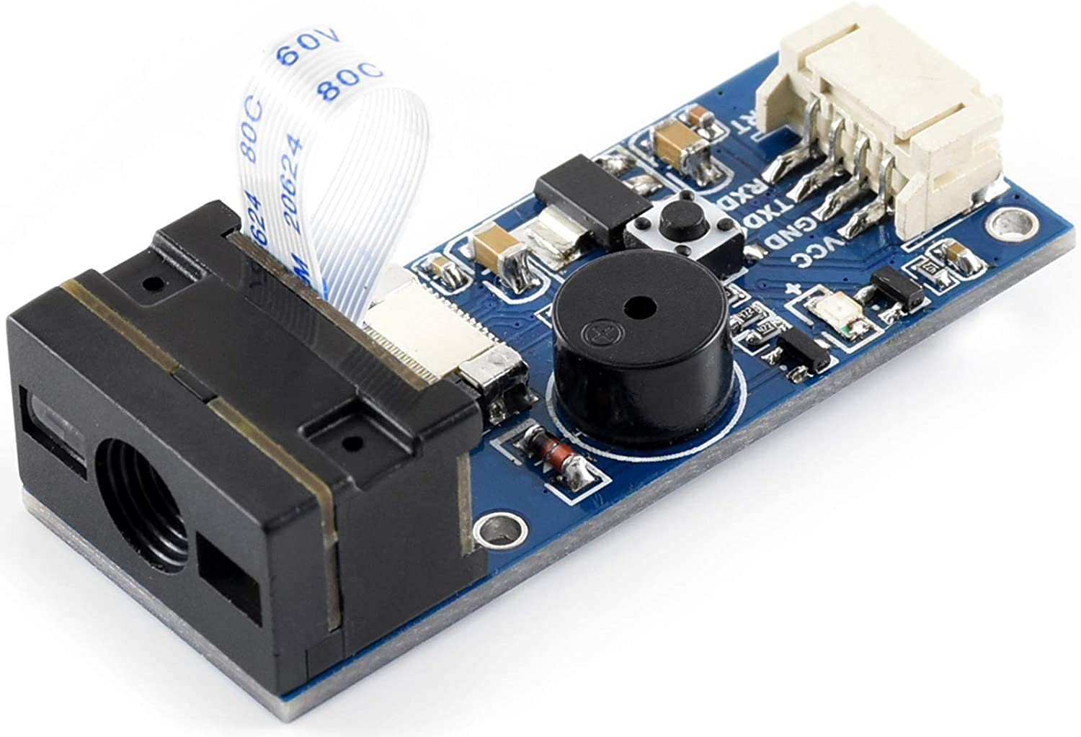

The barcode reader is used to scan the barcodes of the batteries. This device uses tx/rx to transmit data to the raspberry pi 4. This specific barcode reader can be programmed to bypass the activation button. For our device, we elected to have the module constantly running. The barcode scanner receives power through wire connections to the raspberry pi 4.

VGE Battery Pack:

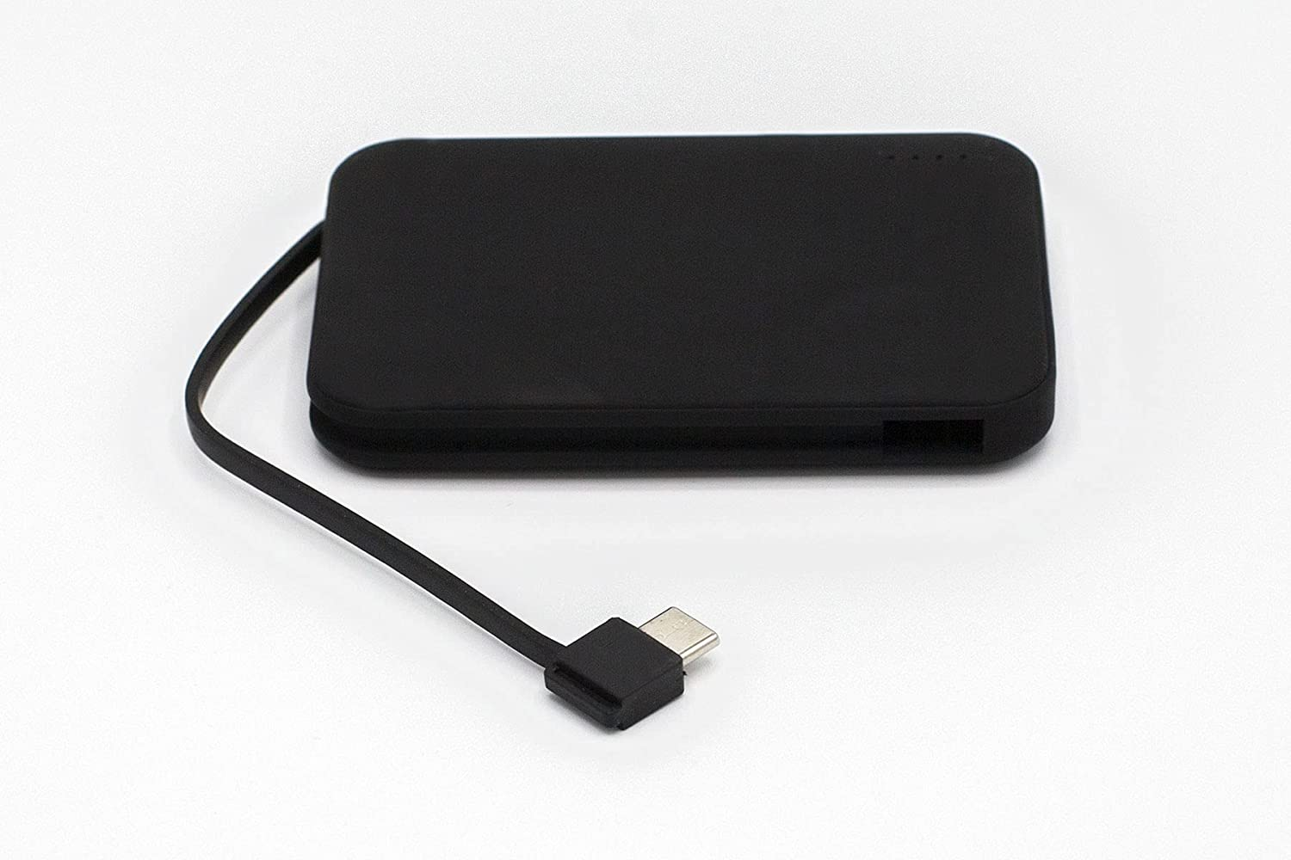

The VGE Battery Pack is capable of providing 5V, 2.4 A and has 4000 mAH. We chose this specific battery pack as the raspberry pi needs 5V to operate, and its able to provide the current all the components needs. The battery pack doesn’t directly power all the components. Instead, it is connected to the raspberry pi 4 via the embedded USB-C. The connected raspberry pi 4 then powers the external components.

Ximimark Audio Amplifier:

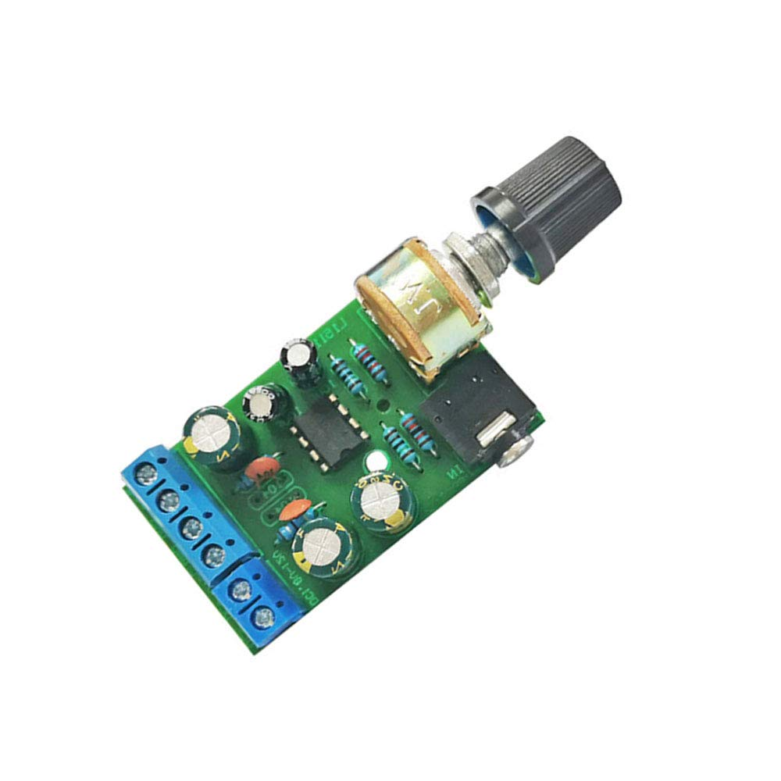

The Ximimark DC TDA2822M Audio Amplifier Board 2.0 can be powered with 1.8V to 12V. We chose this audio amplifier to be able to output the indicator sounds at our own power and volume levels. The amplifier is powered by the Raspberry Pi 4, which powers all of the components except the battery pack. We used a 3.5mm audio cable to connect the amplifier to the audio jack on the Raspberry Pi 4. The amplifier is also connected to the MakerHawk Arduino speaker so we can output our desired sounds.

MakerHawk Arduino Speaker:

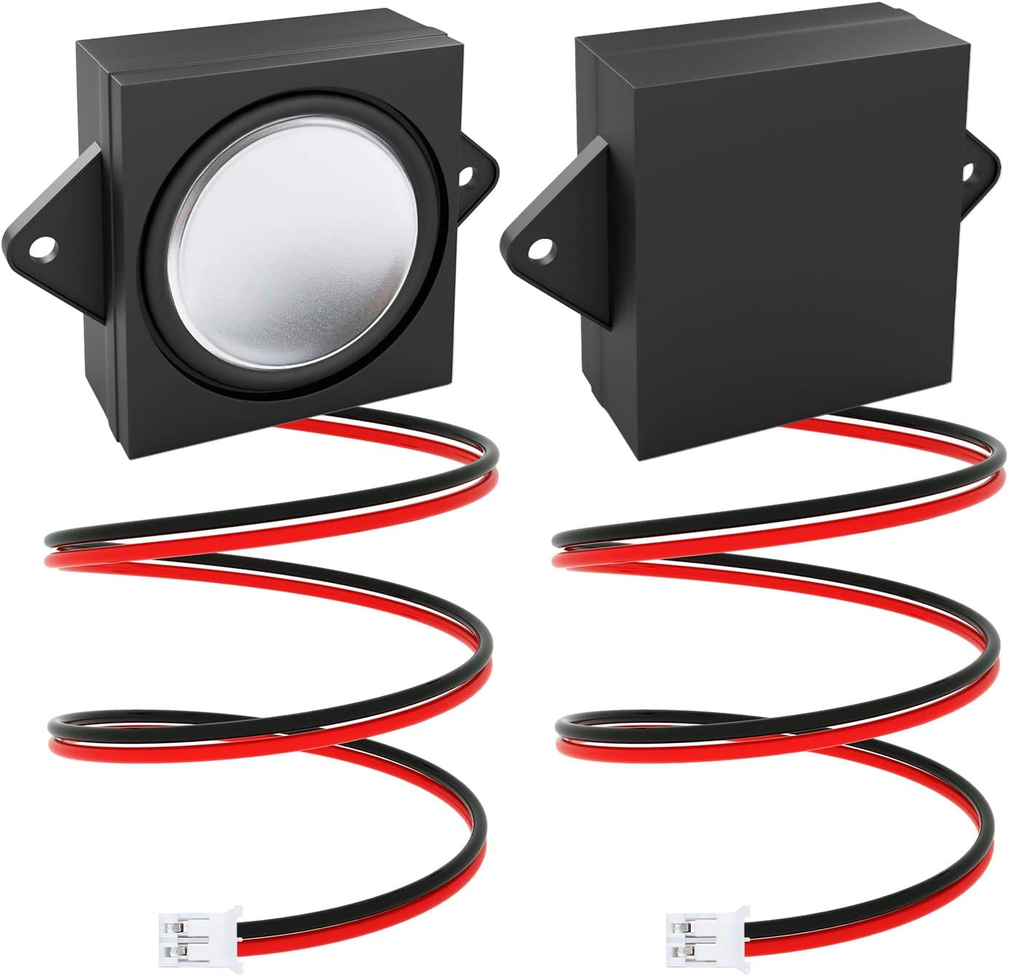

The MarkerHawk Arduino Speaker has an impedance of 8 Ohms and can handle 3W of power. The speaker is powered by the audio amplifier and can operate at 3.3V or 5V of your choosing. We originally were just going to use a piezo speaker but wanted to be able to output a higher quality sound for our indicators. We also chose this speaker because it is smaller in size, and that helps it fit in the casing for our project. If you hear the mario coin sound, the scan was successful. If you hear the mario death sound, the scan was unsuccessful.

**LEDs / Indicators:**

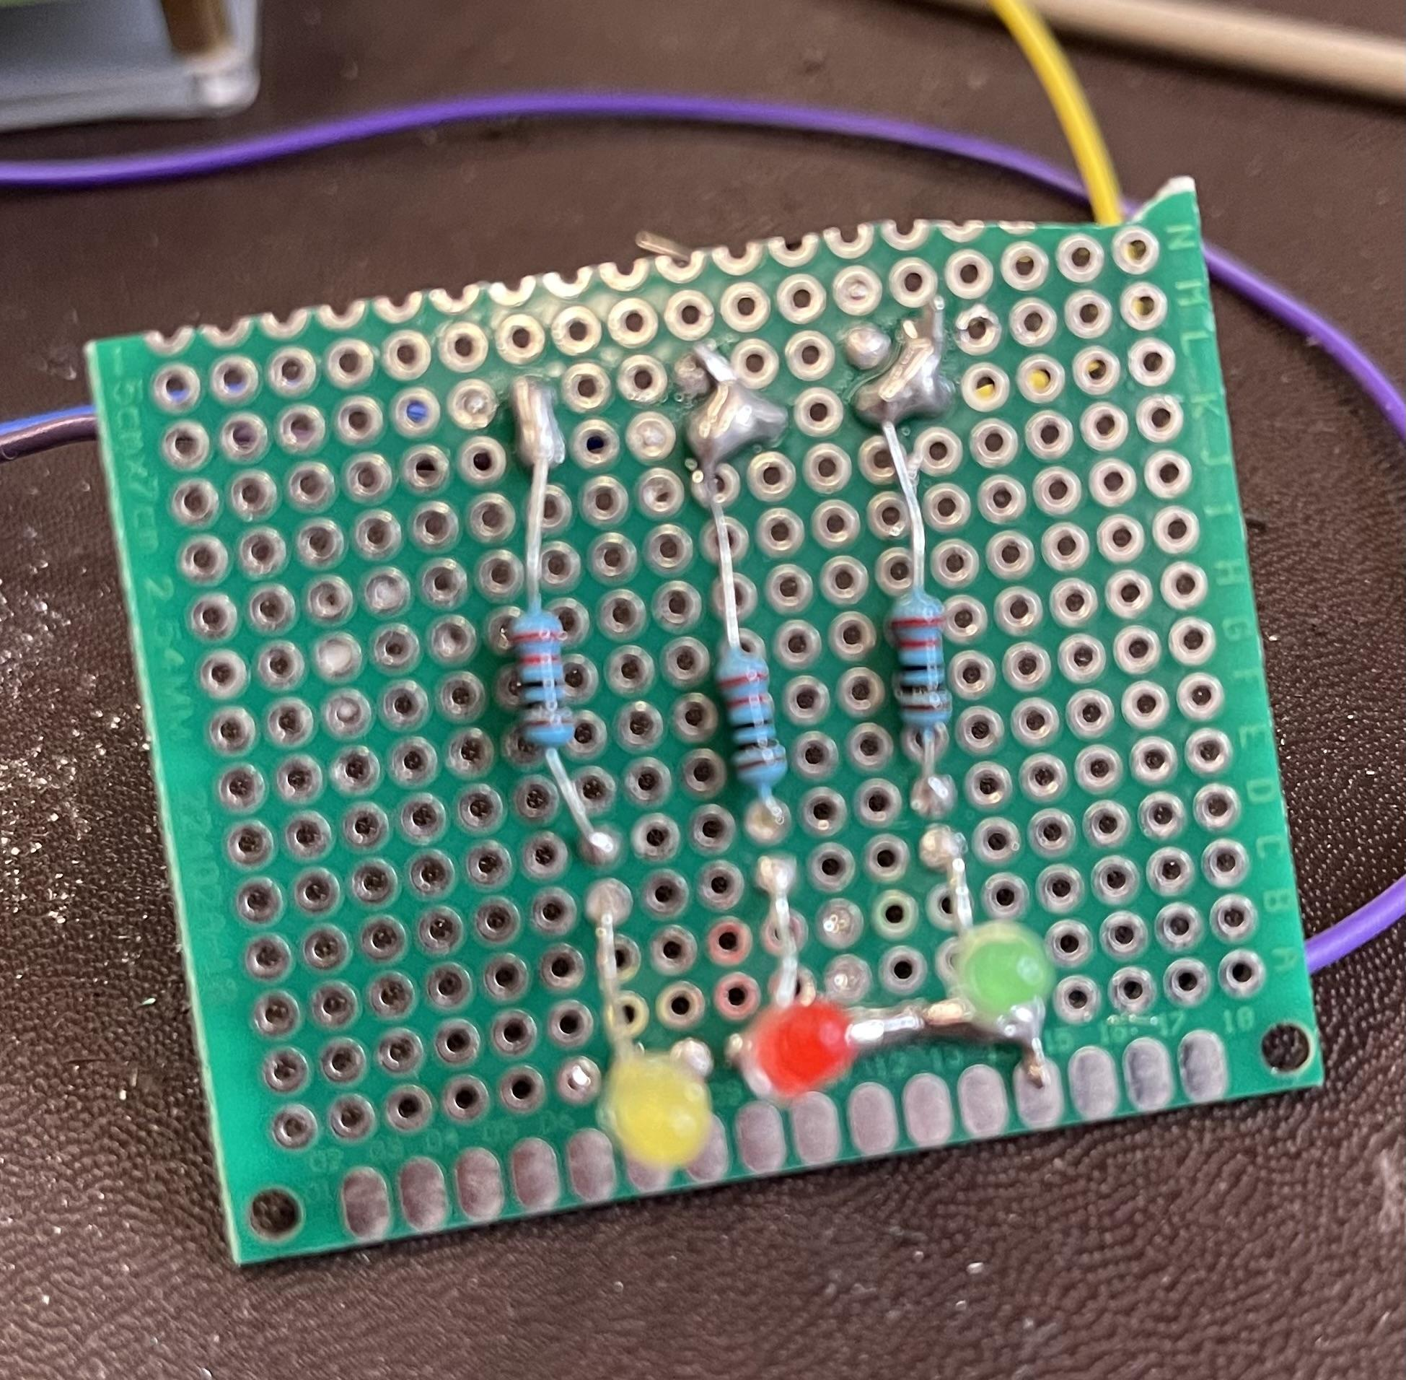

We chose Yellow, Red, and Green LEDs to be our indicators for when a barcode is scanned by the Barcode Scanner Module. All three LEDs are soldered to a 220 Ohm resistor to limit the current through the LED so it does not burn out. There is a common ground soldered on the protoboard as well. All three LEDs are wired to the Raspberry Pi 4. The LEDs are also powered by the Raspberry Pi 4. If the green LED is lit up that means the wand is ready to use and once a barcode is scanned, if it is a battery barcode and is scanned successfully, the green LED will stay lit up. If the red LED lights up, that means the scan was unsuccessful or the barcode was not a battery barcode. If the yellow LED lights up, that means the system is processing the barcode that was scanned.